**Lab Report**

Title: The Order of the Universe: Space and Time Cubes

Notice: Dr. Bryan Runck

Author: Cecelia Isaac

Date: 03/04/2021

**Project Repository:** https://github.com/CeceliaAi/GIS5572/tree/master/Lab2

**Abstract**

The main problem of this lab is to explore 3D data and spacetime data with Python. In part 1a, we will download, transform, and export LiDAR data. In part 1b, we will examine this data. In part 1c, we will download monthly precipitation data and use it to create a spacetime cube and timeseries animation. The data used will be an .laz file of the Central Lakes from MnGeo, and .bil files of precipitation data from PRISM. Both parts of the lab will first require an ETL that downloads and transforms the data. In part 1a, we will then create a layout of the visualizations and export them. In 1c, we will use arcpy to build the spacetime cubes. In both parts, our results will be an export of a file. Part 1a will be two PDF files, and part 1c is a time series animation in ArcPro. Part 1b has no output. The results will be verified by error-free code and the correct output. In this lab we will learn how to display and manipulate 3D data, so the process will answer the main problem, rather than the output specifically.

**Problem Statement**

This lab has three parts which all, broadly speaking, deal with 3D data. Part 1a works with raster data derived from LiDAR, and part 1c with spacetime data derived from annual measurements. The main problem is to download this data and export it in another form. Part 1c has the additional step of creating an animation.

*Table 1. Data*

|  |  |  |  |  |  |  |
| --- | --- | --- | --- | --- | --- | --- |
| **#** | **Requirement** | **Defined As** | **Spatial Data** | **Attribute Data** | **Dataset** | **Preparation** |
| 1 | Convert to DEM and TIN | Take raw LiDAR data to convert it into different raster formats | Point cloud data |  | [Mn GeoSpatial Commons](http://ftp.lmic.state.mn.us/pub/data/elevation/lidar/projects/central_lakes/block_1/laz/) | Convert from LAZ to LAS |
| 2 | Make a spacetime cube | Convert monthly normal data of precipitation into a 3D format | Precipitation normals data over 30 years | Time data needs to be added in a new field | [PRISM](https://prism.oregonstate.edu/normals/) | Convert to TIFF |

**Input Data**

The data for part 1a and 1b is an .LAZ file from MN DNR of the Central Lakes. The data for part 1c are the annual 30-Year normal data for precipitation from PRISM. They are .bil files in a zip file.

*Table 2. Data*

|  |  |  |  |
| --- | --- | --- | --- |
| **#** | **Title** | **Purpose in Analysis** | **Link to Source** |
| 1 | Central Lakes .las | To learn about working with LiDAR data | [Mn GeoSpatial Commons](http://ftp.lmic.state.mn.us/pub/data/elevation/lidar/projects/central_lakes/block_1/laz/) |
| 2 | 30-Year Normals .bil | To convert to 3D animation | [PRISM](https://prism.oregonstate.edu/normals/) |

**Methods***.*

In Part 1a of the lab, first we wrote an ETL to download an LAZ file, and then transform it into an .LAS, and then into a DEM and a TIN. We saved those files to our local machines, and then moved into ArcPro to create two layouts. We then used Python code to download PDFs of the layouts (Figure 1). Finally, we examined the raw LiDAR data in the ArcPro viewer.

*Figure 1. Part 1a data flow diagram.*

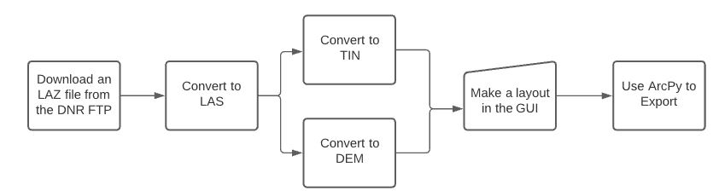

Continuing in Part 1c, we wrote another ETL to get data from PRISM. The data was downloaded as a .BIL file and then transformed into a spacetime cube. This was exported to the local computer and then put into a timeseries animation (Figure 2).

*Figure 2. Part 1c data flow diagram.*

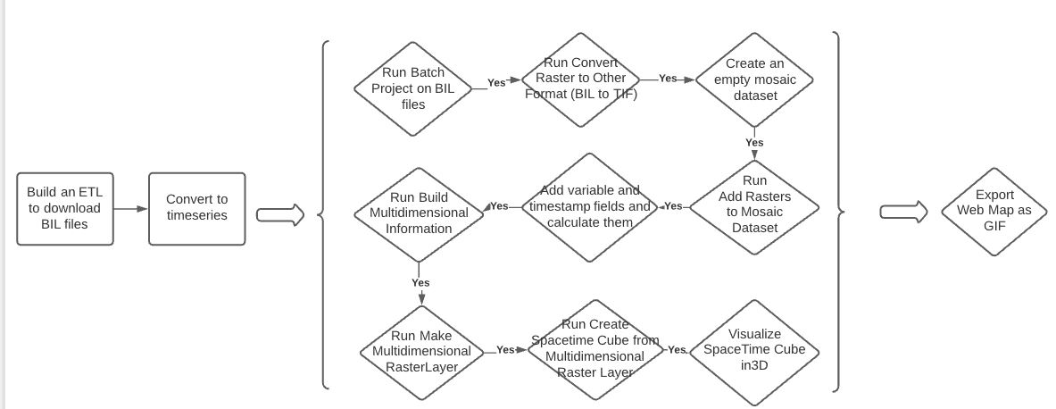

**Results**

The results are two PDF outputs from part 1c, and an animation in ArcPro from part 1c (Figure 3). Our question for part 1b was not necessarily the output but the process of working with LiDAR data. Therefore, the data analysis in part 1b did not have an output because it was more exploratory.

*Figure 3. Exporting the animation as a GIF from the GUI*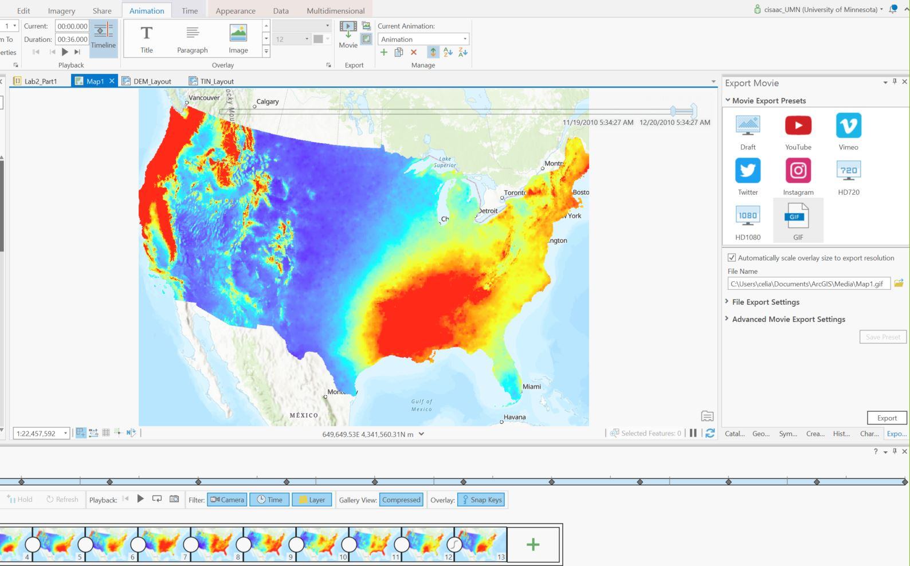

**Results Verification**

We can verify our results by looking at the exported PDFs and spacetime cubes. I also played around with the symbology of the spacetime cubes until the results made logical sense (see Figure 3’s high precipitation levels concentrated in areas like Seattle and New Orleans).

**Discussion and Conclusion**

I learned how to manipulate .LAZ files, including converting to different file types and performing analysis in 2D and 3D. The features for working on LiDAR in 2D allow users to convert to LAS, DEM or TIN surface models to look at elevation or run analyses like slope. Points can be reclassified or symbolized in 2D, and can be combined in mosaic datasets. Point cloud scenes can also be viewed in 3D. ArcPro allows you to make 3D or multipatch geometries, which use the z-coordinates to make elevation models. 3D also has the benefit of producing the world as it actually appears, which can help in map comprehension.

In the final part of the lab, I made another ETL and created spacetime cubes. This was the most arcane section for me. Converting the files was straightforward at first, but since I did not know the endpoint, it took me a long time to realized I had downloaded the wrong files. There were many small, non-intuitive steps to creating the cubes. Ultimately, my process does look a lot like the documentation linked in the lab, but it was not a straightforward path as the documentation might suggest. Though the cubes appeared to draw correctly, it was hard to tell if they were in the right place or otherwise formatted properly. The animation of the timeseries also appeared to be correct but it was hard to verify that from just a visual examination.

Exporting files took a surprising amount of time. In the end I did find a potential way to export files using only Arcpy (as opposed to jumping into the GUI to make a layout first), but it was hidden in the developer tools and I did not find it in time to get a successful output. I was able to export using the GUI.

All of these processes relate to the main problem, which was to explore and analyze 3D data.

**References**

Buie, L. (2020, February 11). Explore your raster data with Space Time Pattern Mining. *ArcGIS Blog*. <https://www.esri.com/arcgis-blog/products/arcgis-pro/analytics/explore-your-raster-data-with-space-time-pattern-mining/>

ESRI. (n.d.). *Tutorial: Getting started with arcpy.mp* [Documentation]. Retrieved February 14, 2021, from <https://pro.arcgis.com/en/pro-app/latest/arcpy/mapping/tutorial-getting-started-with-arcpy-mp.htm#ESRI_SECTION1_CEE9D43FE3B14F8AA9F0B109E9E8F766>

Lenhardt, J. (2020, December 17). How to create multidimensional raster data to use in ArcGIS Pro. *ArcGIS Blog*. <https://www.esri.com/arcgis-blog/products/arcgis-pro/imagery/create-multidimensional-raster-data/>

*Manage Multidimensional Raster (Multidimension)—ArcGIS Pro | Documentation*. (n.d.). Retrieved February 28, 2021, from <https://pro.arcgis.com/en/pro-app/latest/tool-reference/multidimension/manage-multidimensional-raster.htm>

*Use Arcade expressions with Calculate Field—Portal for ArcGIS | ArcGIS Enterprise*. (n.d.). Retrieved February 28, 2021, from <https://gis.fema.gov/arcgis/help/en/portal/latest/use/geoanalytics-calulate-field-expression.htm>

**Self-score**

|  |  |  |  |
| --- | --- | --- | --- |
| **Category** | **Description** | **Points Possible** | **Score** |
| **Structural Elements** | All elements of a lab report are included **(2 points each)**:  Title, Notice: Dr. Bryan Runck, Author, Project Repository, Date, Abstract, Problem Statement, Input Data w/ tables, Methods w/ Data, Flow Diagrams, Results, Results Verification, Discussion and Conclusion, References in common format, Self-score | 28 | **28** |
| **Clarity of Content** | Each element above is executed at a professional level so that someone can understand the goal, data, methods, results, and their validity and implications in a 5 minute reading at a cursory-level, and in a 30 minute meeting at a deep level **(12 points)**. There is a clear connection from data to results to discussion and conclusion **(12 points)**. | 24 | **24** |
| **Reproducibility** | Results are completely reproducible by someone with basic GIS training. There is no ambiguity in data flow or rationale for data operations. Every step is documented and justified. | 28 | **28** |
| **Verification** | Results are correct in that they have been verified in comparison to some standard. The standard is clearly stated **(10 points)**, the method of comparison is clearly stated **(5 points)**, and the result of verification is clearly stated **(5 points)**. | 20 | **20** |
|  |  | 100 | **100** |